Project Design Phase
Solution Architecture

Date | 08/10/2026
Team ID | 9100Byte
Project Name | Implement Client Script & UI Policy (Incident)
Maximum Marks | 4 Marks

Solution Architecture:
The solution architecture for this project connects the ServiceNow Incident form, UI Policy controls, Client Scripts, validation logic, and the Incident table.
- • Improve Incident data consistency using standard ServiceNow configuration.
- • Control field behavior through UI Policies and Client Scripts.
- • Automatically set Urgency, validate Assigned To, and control State list editing.
- • Provide clear client-side behavior before an Incident is saved or updated.

Project Solution Architecture Diagram:

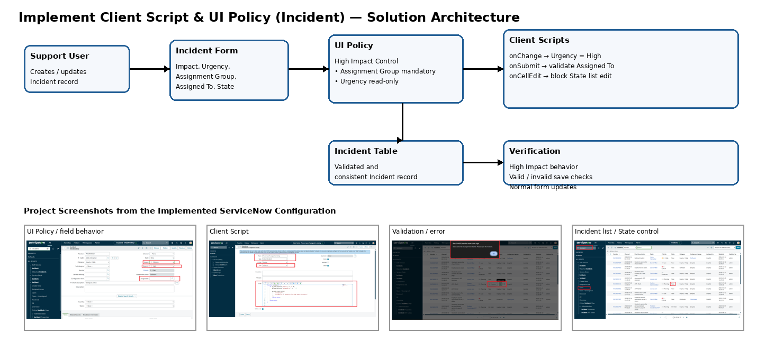
Figure 1: ServiceNow Incident UI Policy and Client Script architecture.
Reference: https://aws.amazon.com/blogs/industries/voice-applications-in-clinical-research-powered-by-ai-on-aws-part-1-architecture-and-design-considerations/

